Angular: Getting Started.

 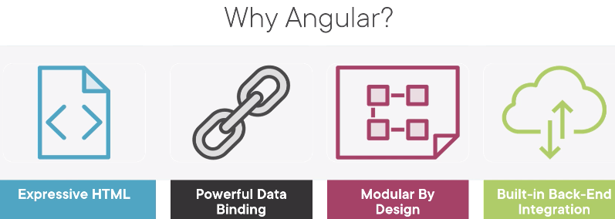

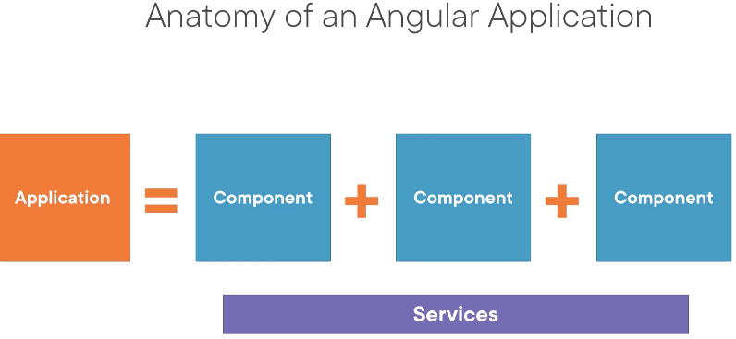 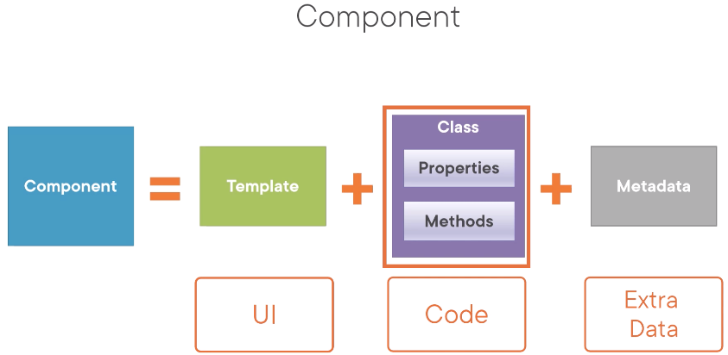

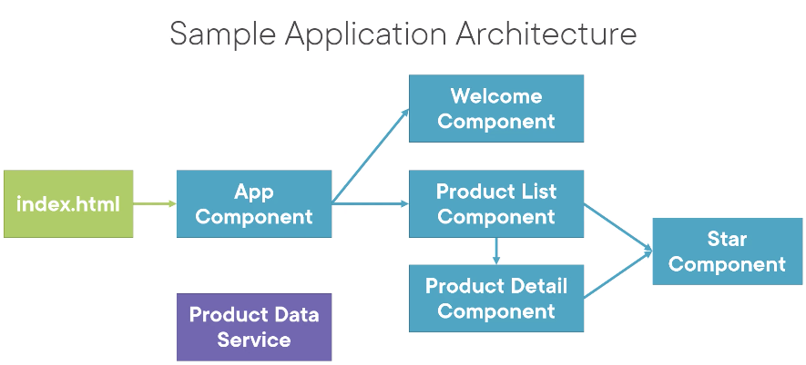

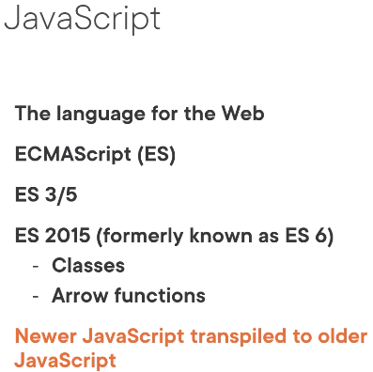 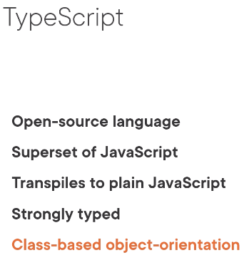

-transpiled means converts newer code to older code

npm

-repository and command line utility for interacting with repository, execute scripts

-we tell npm to use package.json file to install all of the defined packages along with dependencies

-generates node_modules

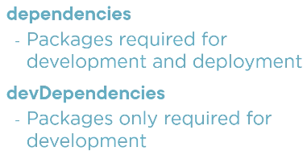

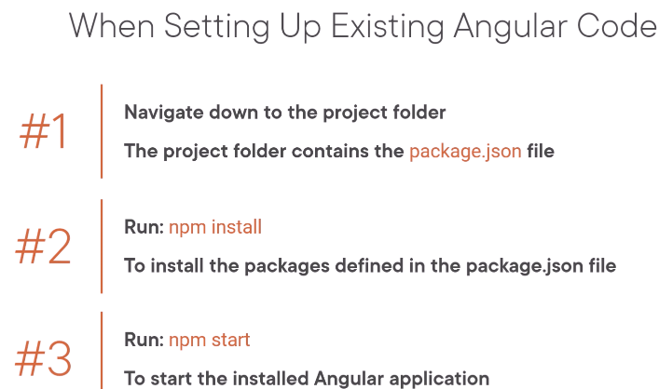

-node_modules files are large so might want to exclude them in source control

npm install -g @angular/cli

-to install the angular CLI globally (ng)

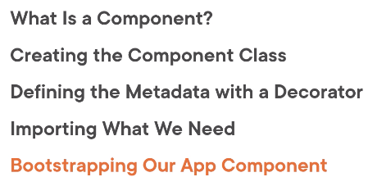 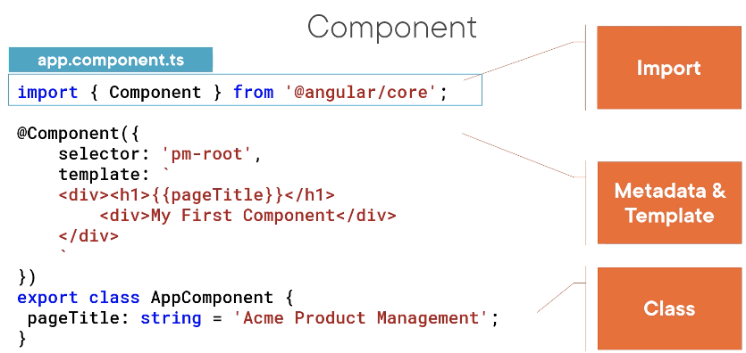

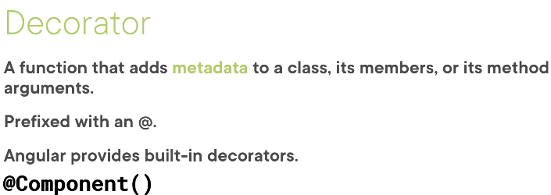

-Angular needs metadata to understand how to instantiate the component, construct the view, and interact with the component

-A directive is simply a custom HTML tag (but definition may not be accurate, ngFor are considered directions)

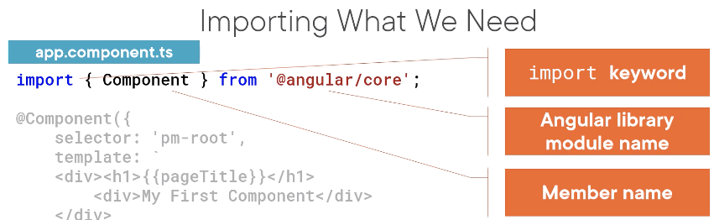

Bootstrap

-self-starting process that loads and goes

-bootstrap array defines the starting component of the application

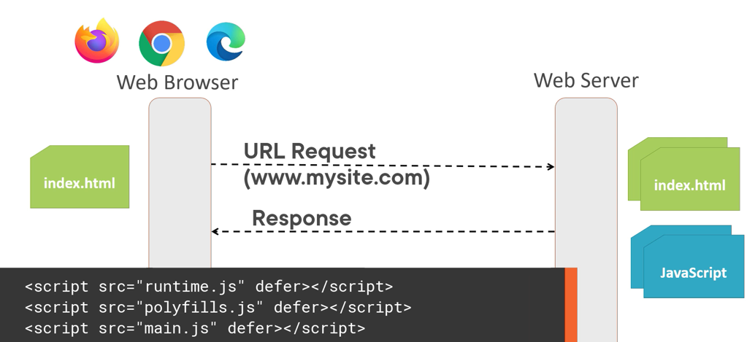

-A user access a url, server associated with that URL is sent a request, server responds with the default web page (index.html), then the browser process the index.html

-For Angular, the index.html contains script tags referencing the application files that were transpiled and bundled into JS files

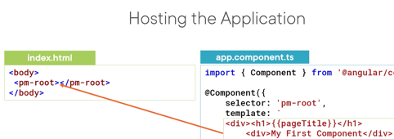

-How does Angular compiler know about the custom HTML element? It looks inside Angular module.

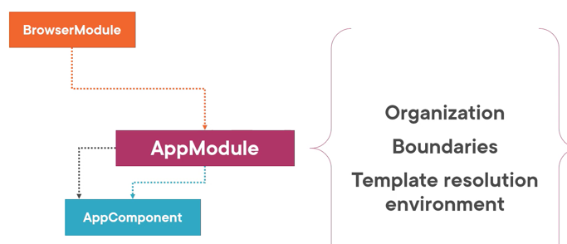

Angular Module

-helps us organize our apps into blocks of functionality

-Template Resolution Env: when Angular compiler sees a directive and a template, it looks to AM for the definition. So declare the AppComponent in AM so the compiler can find it

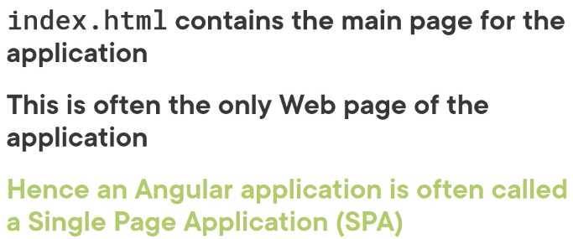

­­-Angular compiles our HTML templates and TS components to JS

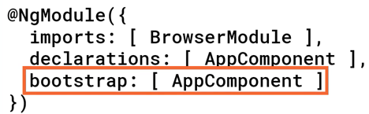

-Bootstrap defines the startup component of the app. The startup component should have the selector in the index.html



-Also remember that components must be declared in Angular module

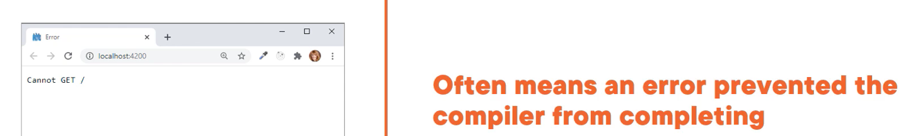

-Means that it didn’t create the JS files that browser needs

Modulations 2: Templates, Interpolation, and Directives

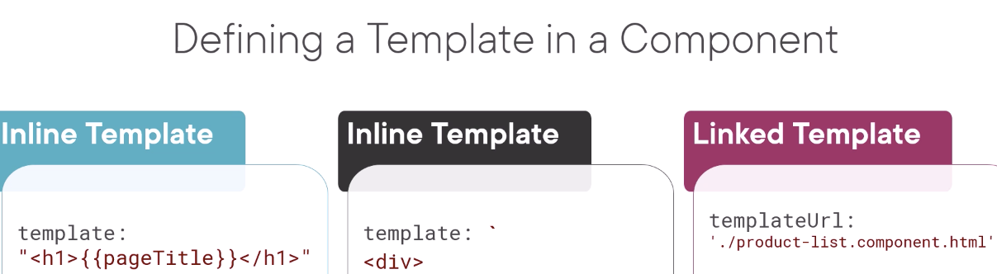

Installing bootstrap packages



style.css

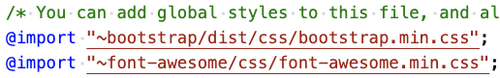

-make the style sheets available to any template in our application

-Angular looks for a component that has a selector with this name. How does Angular know where to look? The application looks to the Angular module that owns this component to find

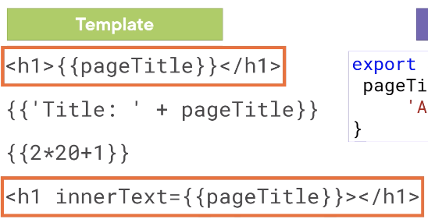



Angular Built-in directives: *ngIf, *ngFor, * marks the directives as structural

-Structural meaning it modifies the structure or layout of the view

-BrowserModule exposes these directives

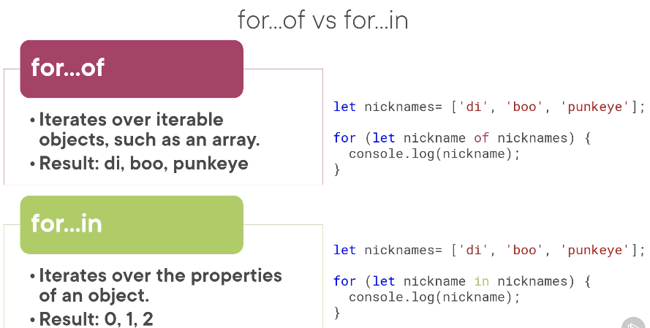

Interpolation





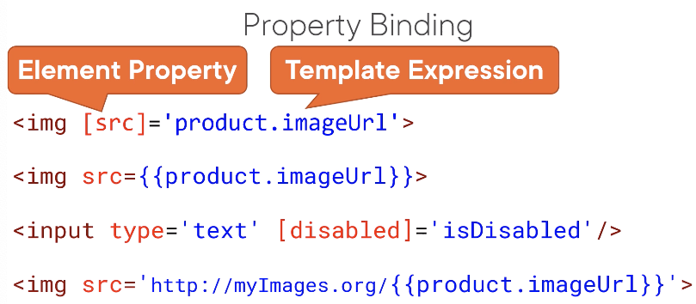

-Property binding allows us to other types other than string

-Like Interpolation, property binding is one way from Component to HTML

Events binding allows us to connect an event to a method in component

Two Way Binding

[()] – event binding inside property binding

-to use ngModule, we must import Forms module in app module

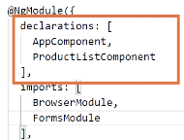

-Our directives, components, pipes are declared in the declarations array

-Angular stuff are defined in the imports array

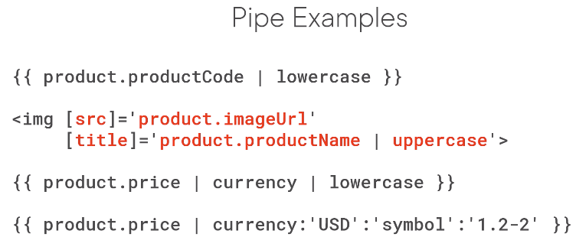

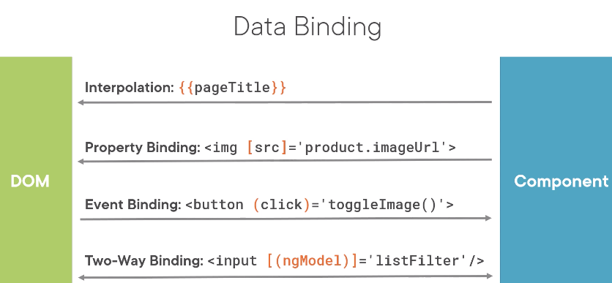

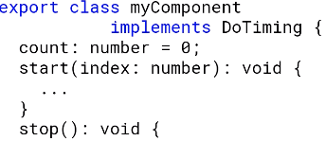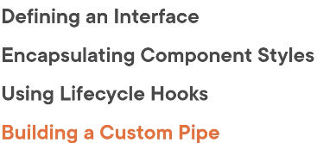

-Interface is a specification identifying a related set of properties and methods

-Use an interface to identify the properties for a specific, unique type

-Two ways to use an interface: as a type or feature set (implements)

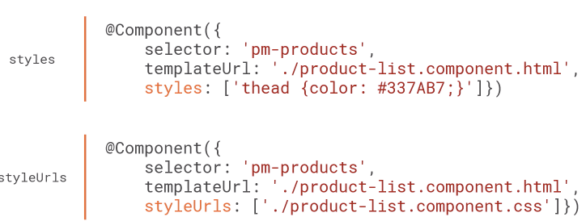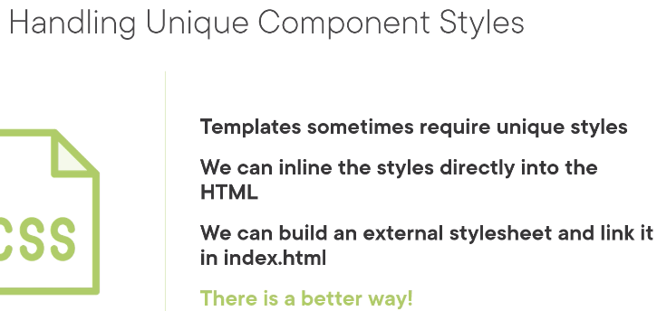

-Inline makes it harder to see, reuse and maintain those styles

-External puts the burden on the container to ensure external style sheet is linked in index.html

Lifecycle hook is an interface we implement to write code when a component lifecycle event occurs

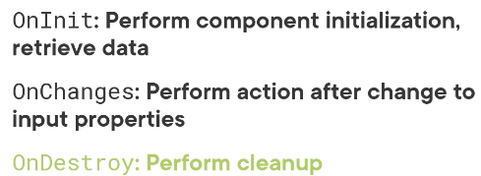

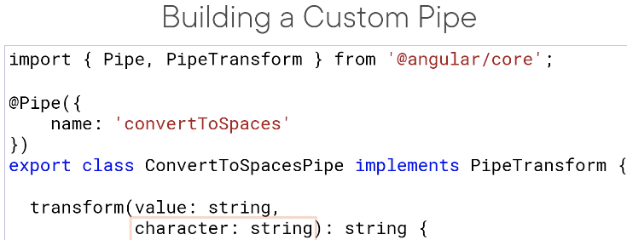

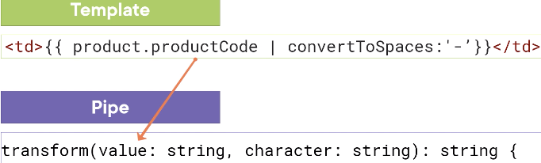

-Also add to the AppModule, if multiple modules we want to add to the module that declares the component that needs the pipe

-Since we added it to the AppModule, no need to import it to the component

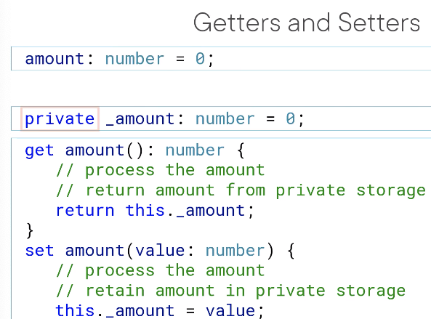

-we prefix it with _ for private variables

Rewatch get/set with two way binding

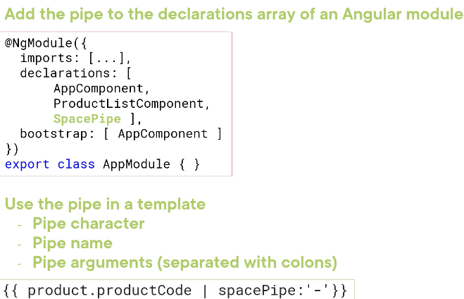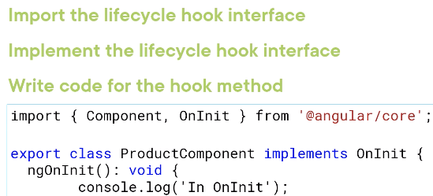

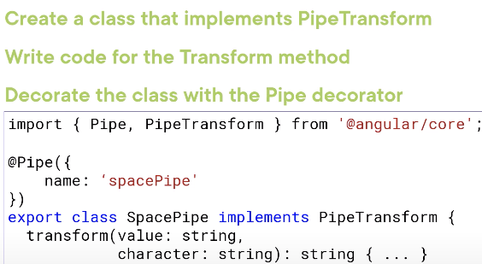

-Any template associated with a component declared in that Angular module can use that pipe

What makes a component nestable?

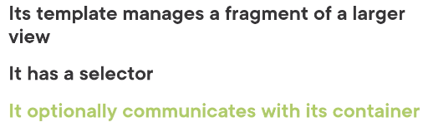

-Rewatch the introduction

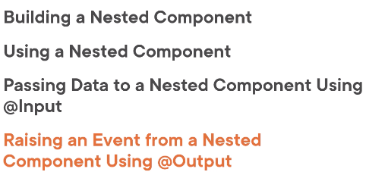

-Refer the outer component as the container or parent, inner as nested or child

-Nested components are still needed to be declared in the app module



-only watches for changes to input properties

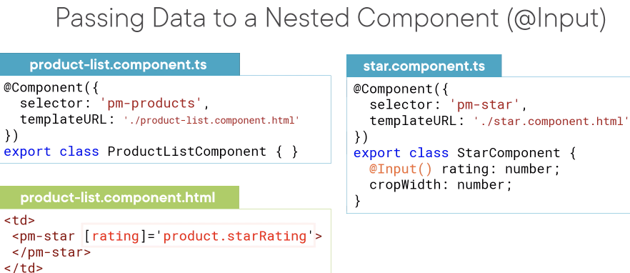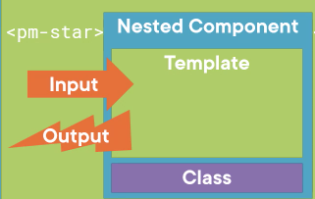

@Input decorator

Inside the html element

@Outputs (events)



-Remember to use backticks when you want to evaluate expression

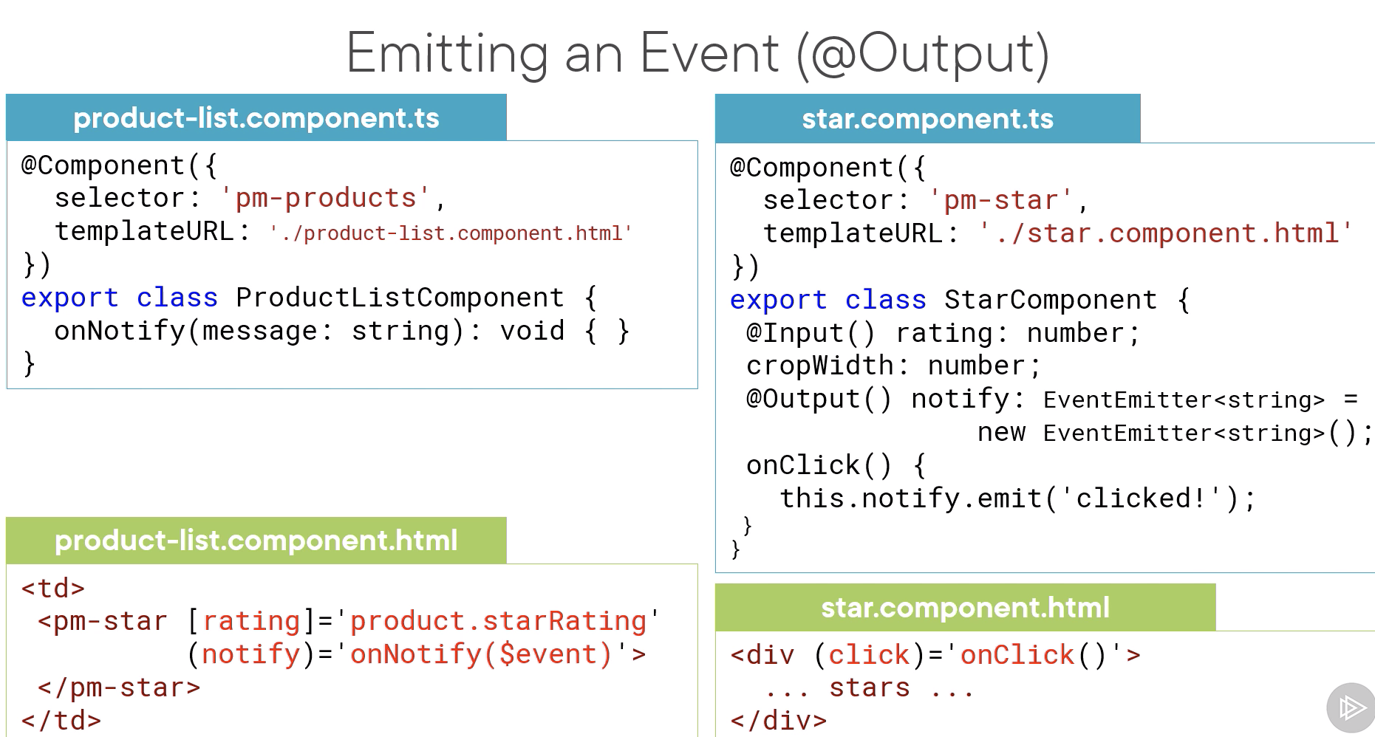

-Output decorator to decorate any property of the Nested Component class

-Only way to pass date from nested to its container is event

-TS supports generics

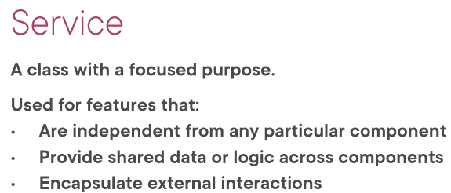

-Component can create an instance of a service but it is only local to the component so we can’t share data, more difficult for testing

-Instead register the service with Angular, then it creates a single instance of the service class (Singleton)



-Angular provides a built in injector, which maintains a container of created service instances

-If component wants to use a service, it defines the service as a dependency

-The Angular injector then injects the service class instance when component is instantiated called dependency injection

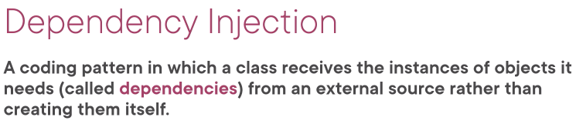

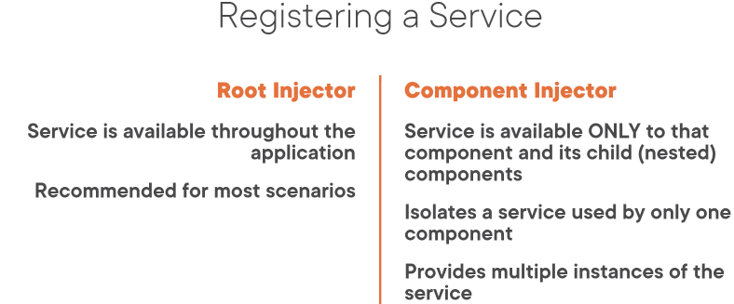

-External source is Angular Injector

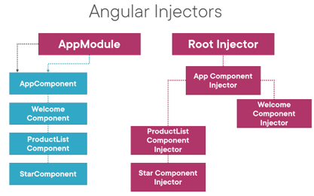

-The service does not need to be defined in the Angular Module

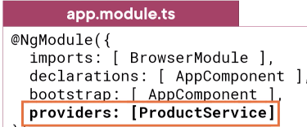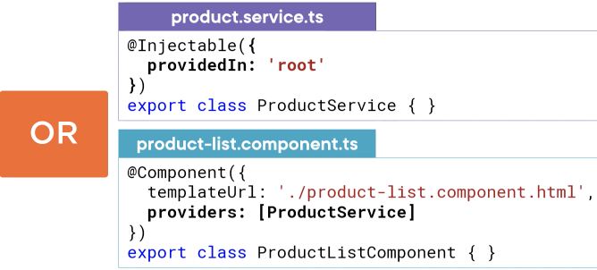

-providedIn feature is newer and recommend



-To inject the service

OnInit lifecycle hook provides a place to perform any component initialization



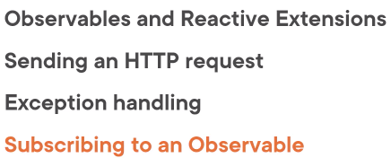

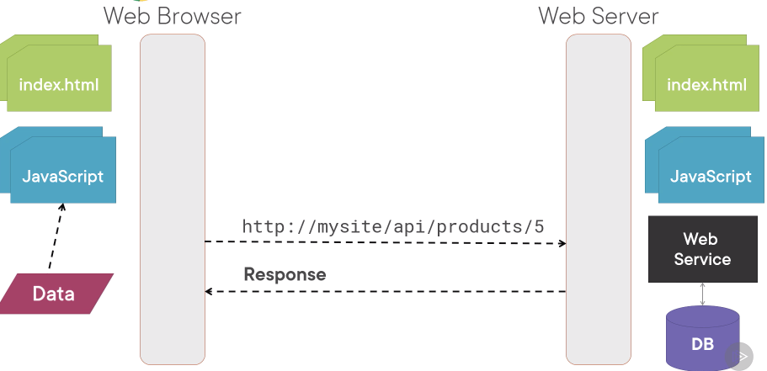



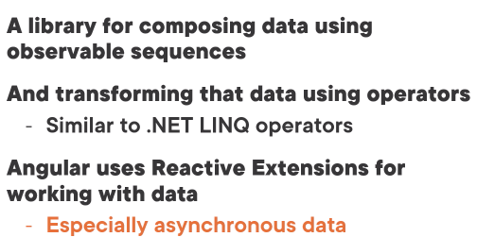

-Synchronous is when apps requests a value and waits for it to arrive

-From our POV, HTTP requests are asynchronous

-Use RxJS Observable to get notifications when data arrives

-Observable sequence/stream are a collection of items over time

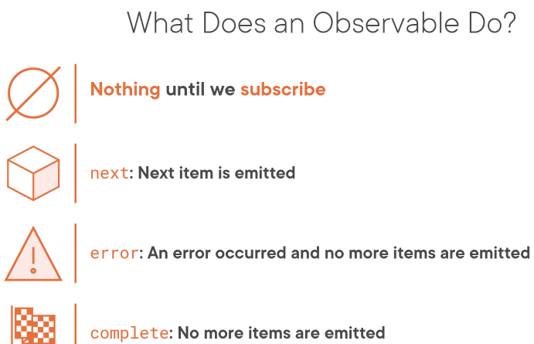

-When we subscribe, the Observable begins emitting notifications

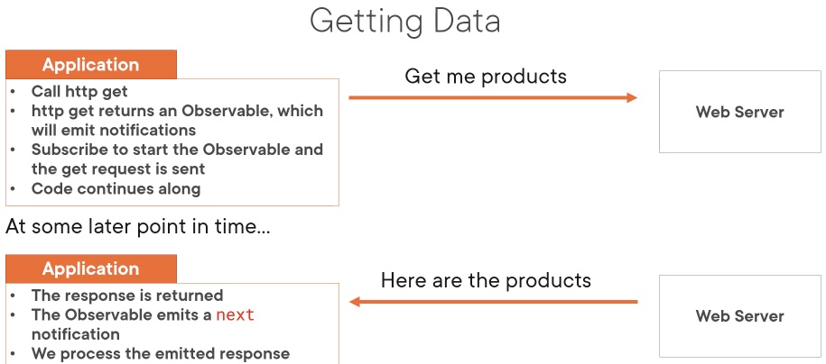

-When HTTP Get, the Observable emits the entire response as one emitted item

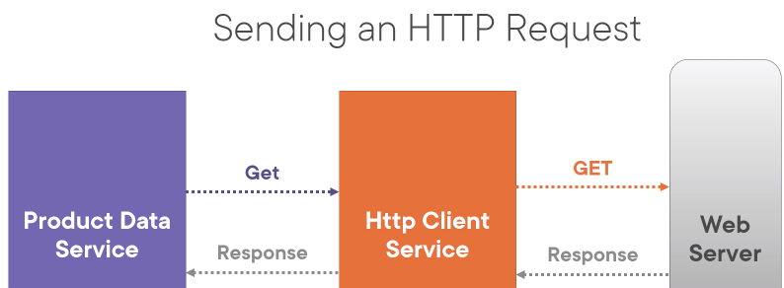

-Call the get method of HttpClient Service which returns an observable

-When we subscribe to the observable, the HTTP Client service sends a get request to the web server

-The web server response is returned to the HttpClient service and the observable emits the next notification

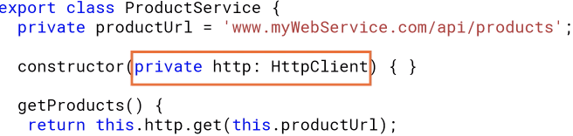

-Also need to import it in App module in the imports [] (for external modules)

-declarations are for components, directives and pipes

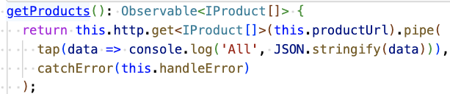

-Recall that HTTP GET returns an observable

-Call the observable pipe method to specify a set of operators

tap: access the emitted item without modifying it

catchError: handles error

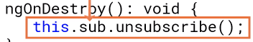

Unsubscribe from an Observable

-Store the subscription in a variable then implement the OnDestroy lifecycle hook

-Use the subscription variable to unsubscribe

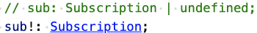

-The bang (exclamation point) tells the TS compiler that we will handle the assignment later

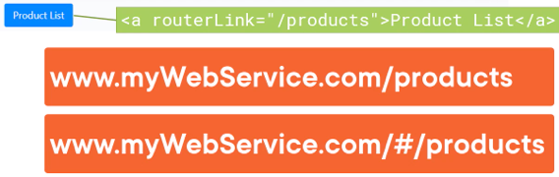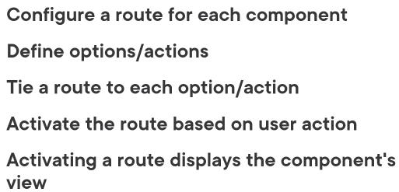

-Angular application is a single page application (SPA)

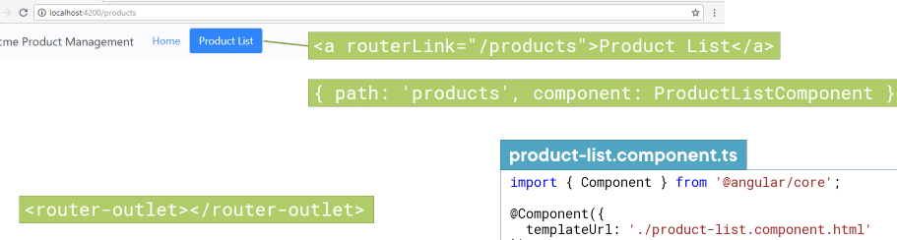

-Angular provides a router module and must import in App Module

-Router modules: registers the route service, declares the router directices (rounter link/outlet), exposes configured routes

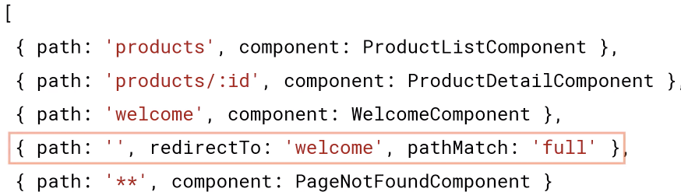

-* denotes a wildcard path

-The router uses a first match strategry so the order matters



-The first step to set up routing is to define a base element in the head tad of index.html

-This element tells the router how to compose the navigation URLs

Navigating the Application Routes

-Menu option, link, image or button that activatses a route

-Typing the Url in the address bar

-The browser’s forward or back button

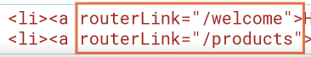

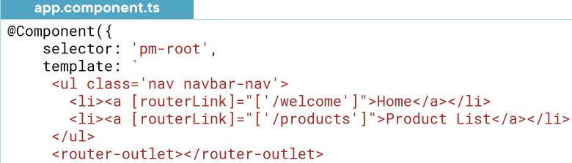

-If the array only contains the route path, we can use shortcut syntax like this

-Can’t use the shortcut if the array contains multiple elements when passing parameters

-Place the router-outlet directive in the host component’s template (not index.html?)

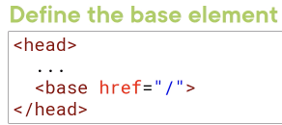



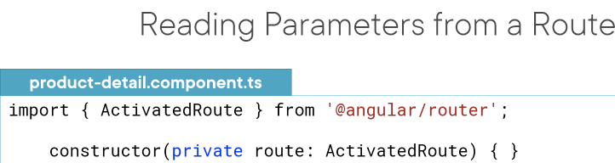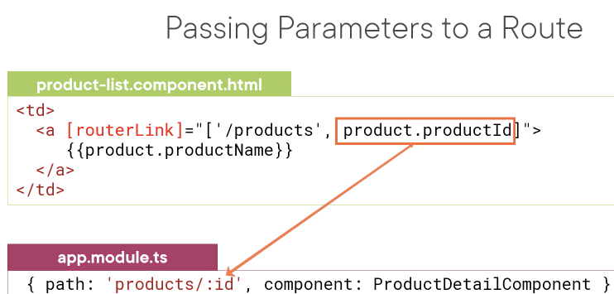

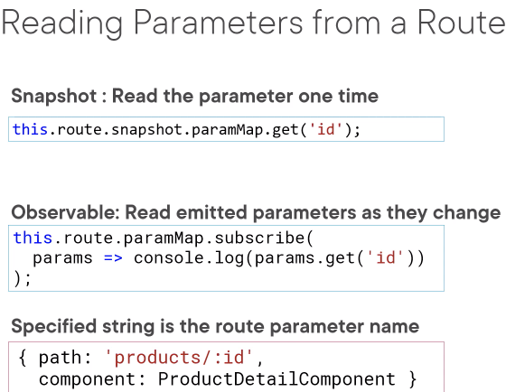

-Snapshot gives us route information at a single poin time

-Observable might be useful for using forward and back buttons

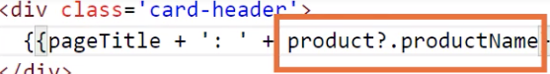

-If the project is null or undefined, the safe navigation operator simply returns null and does not attempt to access

-Doesn’t work with [(ngModel)] and can be tedious for to put for all. Instead use *ngIf

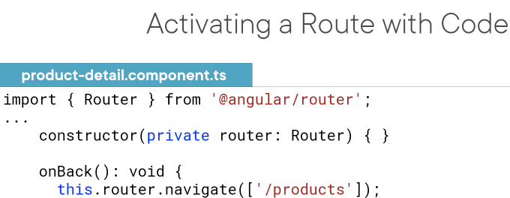

-

Protecting Routes with Guards

-limit access to a route, restrict access to only certain users, require confirmation before navigating away

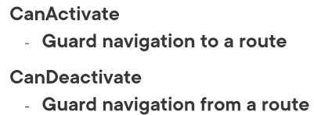 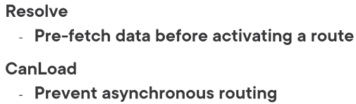

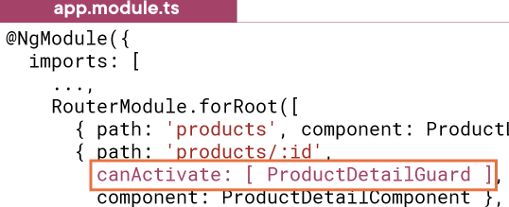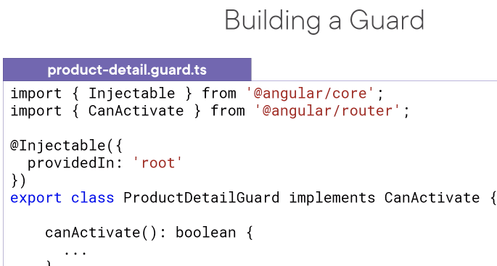

-Guard is a service so we need injectable dectorator

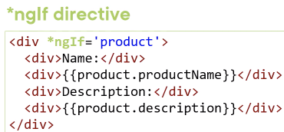-canActivate can also return an observable or promise

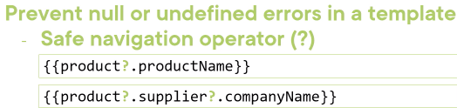

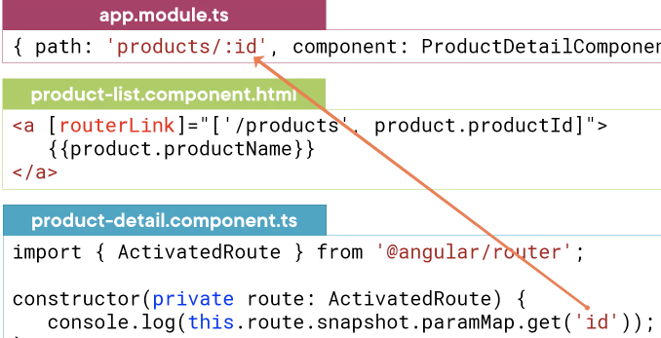

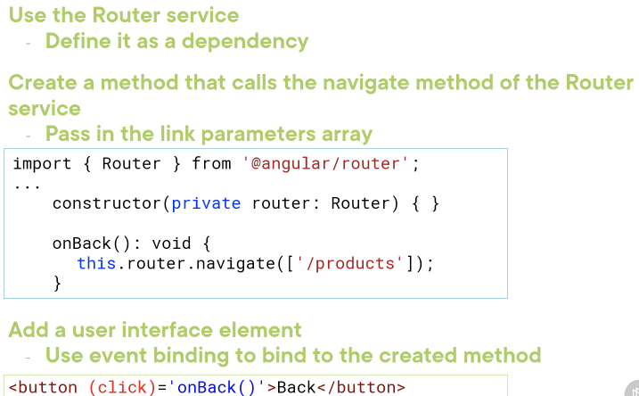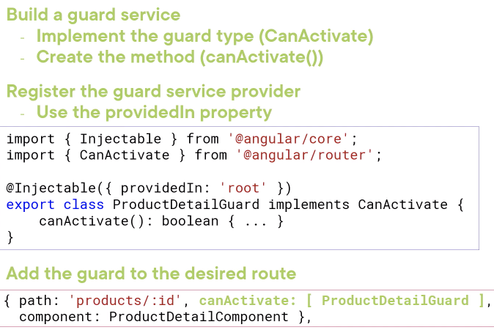

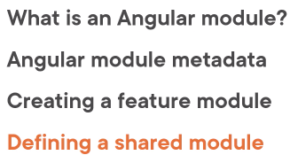

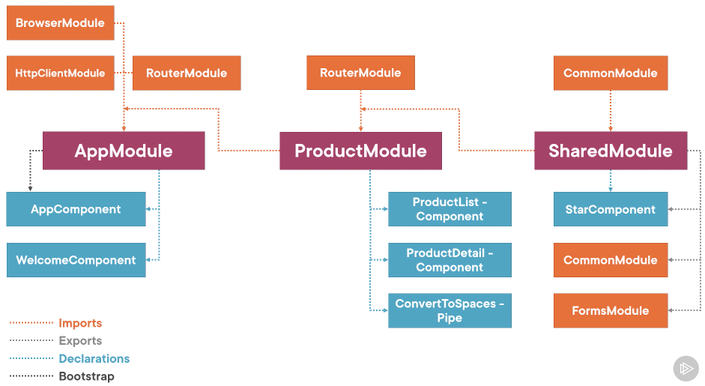

-Leverage the power of Angular modules, instead of one large AppModule

Bootstrap Array

-defines the component that is the starting point of the application

-should only be used in root app module (AppModule)

Declarations Array

-Every component, directive, and pipe we create must belong to only one Angular module

-All declared components, directives, and pipes are private by default. Only accessible to other components, directives and pipes declared in the same module

-The Angular module provides the template resolution environment for its component templates

Exoprts Array

-We can export something without including it in the imports array. The imports array only needs to import the modules that are required by the components declared in the module but the Angular module can still provide capabilites to other modules that import it by reexporting

Import Array

-Adding a module to the imports array makes available any components, directives, and pipes defined in that module’s exports array

-Importing a module does not proves access to its imported modules. Imports are not inherited

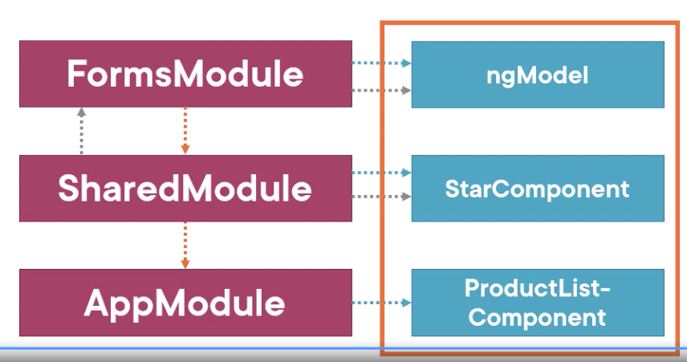

-However if SharedModule reexported the FormsModule, then the FormsModule exports are available to the AppModule

-Normally, we add a module that registers a service to the import arrays of the AppModule. This ensure it services are registered one time when the application is initialized

Providers Array

-Use it to register our service with the root application injector but use providedIn

Browser Module

-module that every browser application must import

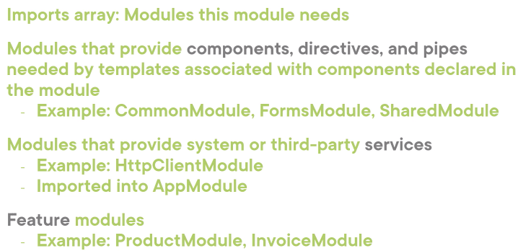-imports and exports common module (ngIf/ngFor)

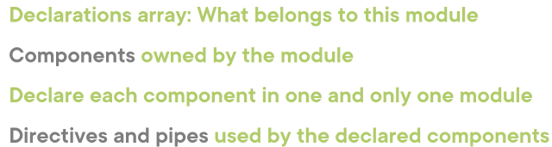

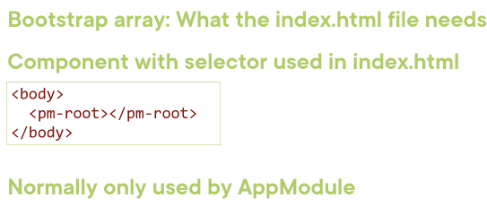

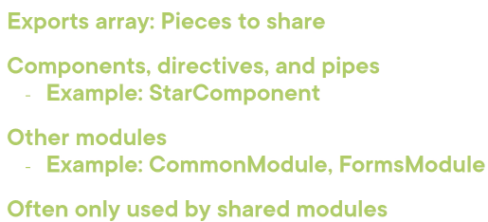

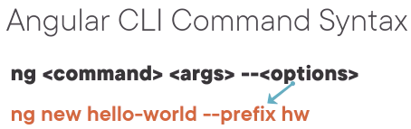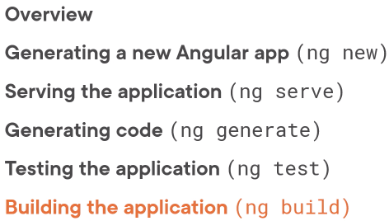

Node_modules

-contains all of the libraries

Src

-folder contains the source code for our application

Src/app: add all fo the module’s component, services, and other files

Src/assets: images

Src/environment: picks the environment based on the flag we use

Polyfills.ts

-supports both evergreen and classic browsers

-adds code to allow functionality written for modern browsers to work

Angular.json

-CLI configuration file for our local installed CLI



-complies the app, generates application bundles, starts a local web server, serves the application from memory, rebuilds on file changes

-o is an alias for –open flag, which opens the default browser

Webpack is the technology behind the compilation and bundling process

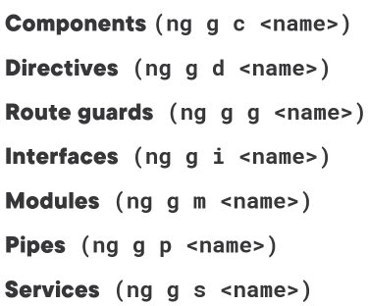

Tree shaking

-shakes up our code to drop out any dead branches, means it removes any unused pieces

ng build

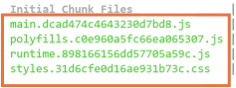

-They have a hash as part of the file name, for cache busting

-Everytime we update our code, it gets redeployed to the server. We expect the new files to be downloaded by the browser when a user accesses out application

-But for performance reasons, the browser may have cached those files by changing the file name using a hash, the browser will download the latest version because the file names won’t match its cached versions